**ABOUT US**

Based in Seattle, Washington, Optima have been in operation since 2014. A member of the Seattle Chamber of Commerce, Optima is a licensed engineering company in the State of Washington. We’re certified by OWMBE as DBE and MBE in Washington and certified by Caltrans as DBE in California. We have delivered engineering and management consulting projects for government agencies and multinational corporations in the US, Asia and Africa.

**Shobuz Ikbal**  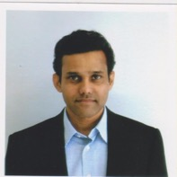

President/ Practice Leader – Engineering

BSc MSc PE PMP

Mr. Ikbal is an international development professional with 29 years of experience managing and delivering infrastructure projects. He has BSc in Civil Engineering from University of California and MSc from California State University Los Angeles and he is a licensed engineer in the states of California and Washington. He has held leadership roles in various private and government entities in the US and Canada. As international consultant to World Bank and ADB, Mr. Ikbal has designed and built infrastructure projectsin Africa, Asia and Europe. He is an adjunct faculty for International Project Management at North Seattle College in Washington.

**Aleya Ikbal** 

Vice President/ Practice Leader – Business Transformation

BBA PMP CSM

Aleya Ikbal is a technology leader with experience in project/program management, IT operations management andbusiness process re-engineering. In her career spanning over 20 years, she has held leadership roles in government and private sector in IT, finance, manufacturing, pharmaceutical, and telecommunication in the US and Asia.

Ms. Ikbal has a BBA in MIS from California State University and executive certificates from Harvard University and University of Washington.She is a certified PMP and Scrum Master and a training specialist.

**Charles Lappenbusch**  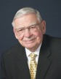

Practice Leader – Project Control and Risk Management

MBA CCP EVP PSP

With BA and MBA from University of Washington, Mr. Lappenbusch has over 30 years of project management and financial experience in Alaska and Washington. He is an expert on Earned Value Management and Risk Management and has taught courses at University of Washington. He sits on the board of directors at American Association for Cost Engineers and leads the development of EVP practice guidelines.

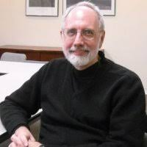

**Dr. Ernest L. Hughes, Chief Innovation Officer, Hughes Global**

Practice Leader – Innovation and Business Strategy

Dr. Hughes provides consulting, education, training, coaching and facilitation in Organization & Leadership Development, Innovation and Change Management, and Supply Chain Management utilizing systems approaches. Domains include: Business, Education, Logistics, Government, Retail, and Small & Medium Enterprises (SMEs). Dr. Hughes has an MS in Global Supply Chain Management from the University of Alaska; a Doctorate in Education (Ed.D.) and a Masters in Software Engineering from Seattle University and an MBA from California State University, Bakersfield.

**Gary Johnson, PE** 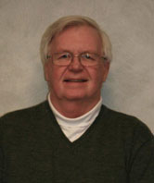Senior Electro-Mechanical Engineer

Gary has 45 years of experience with design, construction and project management of various electrical and mechanical facilities. Over 28 year period at Tacoma City Light Engineering Department, he held a variety of engineering positions such as chief planning engineer and manager of special projects, planning and facilities. Gary also has served as the MEP Quality Control Manager on 10 US Military projects.

B.Sc. Mechanical Engineering, University of Washington  
Construction QM, US Army Corps of Engineers

**Dr. Mahamouda Salouhou**  

Practice Leader – Executive Education

PhD University of Lille, France

Dr. Salouhou is the director of European Center for Leadership Education and Entrepreneurship (ECLEE) in Lille, France and president of Djagora University in Ghana. He has experience in designing and delivering executive programs in France, Morocco, Russia and the US. His expertise includes Leadership, Executive Education. Life Long Learning, Lean Health Care, Cross Cultural Diversity and Communication, International Business and Globalization.



**Sarah Beg**

Practice Leader – Data Science

Data Scientist and BI expert with years of successful experience in applying combination of business, analytical and leadership skills to solve complex problems using various data science tools and technologies. Extensive experience in Business Intelligence management in various phases of SDLC/Agile process, from requirements gathering to advanced solutions development and delivery management. Worked with every level of Sales, Customer Care, IT and other organizations to manage mission critical business solutions.

**Shana Carmody** 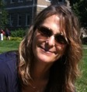

Consultant – Information Technology

BA HIT ITIL

With a BA from University of Washington, Ms. Carmody has over 15 years of experience in Information Technology management. With an innate ability to analyze and synthesize business requirements, Ms. Carmody works as a bridge between the business problem and the technology solution, Ms. Carmody has contributed to the success of local, regional and global companies, such as JP Morgan Chase, Washington Mutual Bank, Safeco Insurance, Nordstrom, and the City of Seattle.

**Philip D. Larson**  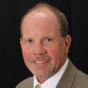

Consultant – Cost Management and Engineering

Mr. Larson is a Project Management and Cost Management expert who brings hands on industry experience to the classroom. With BA in Architecture from Washington State University, he has over 30 years of experience in developing state of the art cost management systems. Mr. Larson was president of the American Association for Cost Engineering and has established training programs throughout the US and China.

**Ron Barnhart** 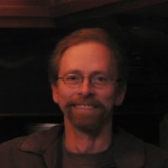

Consultant – Business Analysis

Mr. Barnhart is a senior IT consultant with expertise in

Business Strategy Alignment

Business Architecture Analysis

Systems Integration

Business Intelligence System Implementation

Data Warehouse Implementation

Master Data Management System Implementation

Data Quality Management Solutions

**Mithun Mukherjee** 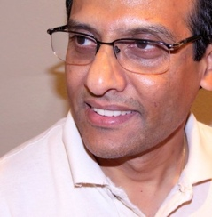

Consultant – Application Development

Mr. Mukherjee is a Business Analyst and Data Architect. His experience includes managing several database enhancements and data migration projects for T-Mobile USA. He completed over 20+ medium to large scale implementations and database migrations projects from legacy Oracle RDB databases to Oracle 11gR2.

B.Com, St. Xavier’s College, Calcutta, India

Oracle DBA, University of California Los Angeles